**NotesHub**

**(noteshub.co.in)**

**Web Engineering Lab File**

**6th Semester**

**To contribute, mail the files or contact us at** [**support@noteshub.co.in**](mailto:support@noteshub.co.in)

**EXPERIMENT – 1**

**AIM**

Design a static home page based on your interest (using basic HTML tags).

**SOURCE FILE**

<html>

<head>

<title>Sania Mirza</title>

</head>

<body bgcolor="black">

<font size="7" color="red"><center><b>SANIA MIRZA</b></center></font>

<marquee>

<img src="C:\Users\anureet kaur\Desktop\college\6_Sem\Web_Engineering\sm1.jpg" height="200" width="200">

<img src="C:\Users\anureet kaur\Desktop\college\6_Sem\Web_Engineering\sm2.jpg" height="200" width="200">

<img src="C:\Users\anureet kaur\Desktop\college\6_Sem\Web_Engineering\sm3.jpg" height="200" width="200">

<img src="C:\Users\anureet kaur\Desktop\college\6_Sem\Web_Engineering\sm4.jpg" height="200" width="200">

</marquee>

<p><font face="Comic Sans MS" color="white" size="4">

Sania Mirza (pronounced [saːˈnɪaː mɪrzaː]; born 15 November 1986) is an Indian professional tennis player who was formerly ranked No. 1 in the women's doubles rankings.From 2003 until her retirement from singles in 2013, she was ranked by the Women's Tennis Association as India's No. 1 player, both in singles and doubles. Throughout her career, Mirza has established herself as the most successful female Indian tennis player ever and one of the highest-paid and high-profile athletes in the country.

</font></p>

<p><font face="Comic Sans MS" color="white" size="4">

In her singles career, Mirza has notable wins over Svetlana Kuznetsova, Vera Zvonareva and Marion Bartoli; as well as former world No. 1s Martina Hingis, Dinara Safina, and Victoria Azarenka. She is the highest-ranked female player ever from India, peaking at world No. 27 in singles in mid-2007; however, a major wrist injury forced her to give up her singles career and focus on the doubles circuit, where she is currently ranked No. 1. She has achieved a number of firsts for women's tennis in her native country, including surpassing US$1 million in career earnings (now over $6 million), winning a singles Pro-level title, and winning six major titles (three each in women's doubles and in mixed doubles), as well as qualifying for (and eventually winning) the WTA Finals in 2014 alongside Cara Black, defending the title the following year partnering with Martina Hingis.

</font></p>

<p><font face="Comic Sans MS" color="white" size="4">

In addition, she is the third Indian woman in the Open Era to feature and win a round at a Grand Slam tournament, and the first to reach the second week. She has also won a total of 14 medals (including 6 Gold) at three major multi-sport events, namely the Asian Games, the Commonwealth Games and the Afro-Asian Games.

</font></p>

<p><font face="Comic Sans MS" color="white" size="4">

Mirza was named one of the "50 Heroes of Asia" by Time in October 2005.In March 2010, The Economic Times named Mirza in the list of the "33 women who made India proud". She was appointed as the UN Women's Goodwill Ambassador for South Asia during the event held to mark the International Day To End Violence Against Women on 25 November 2013. She was named in Time magazine's 2016 list of the 100 most influential people in the world.

</font></p>

</body>

</html>

**OUTPUT**

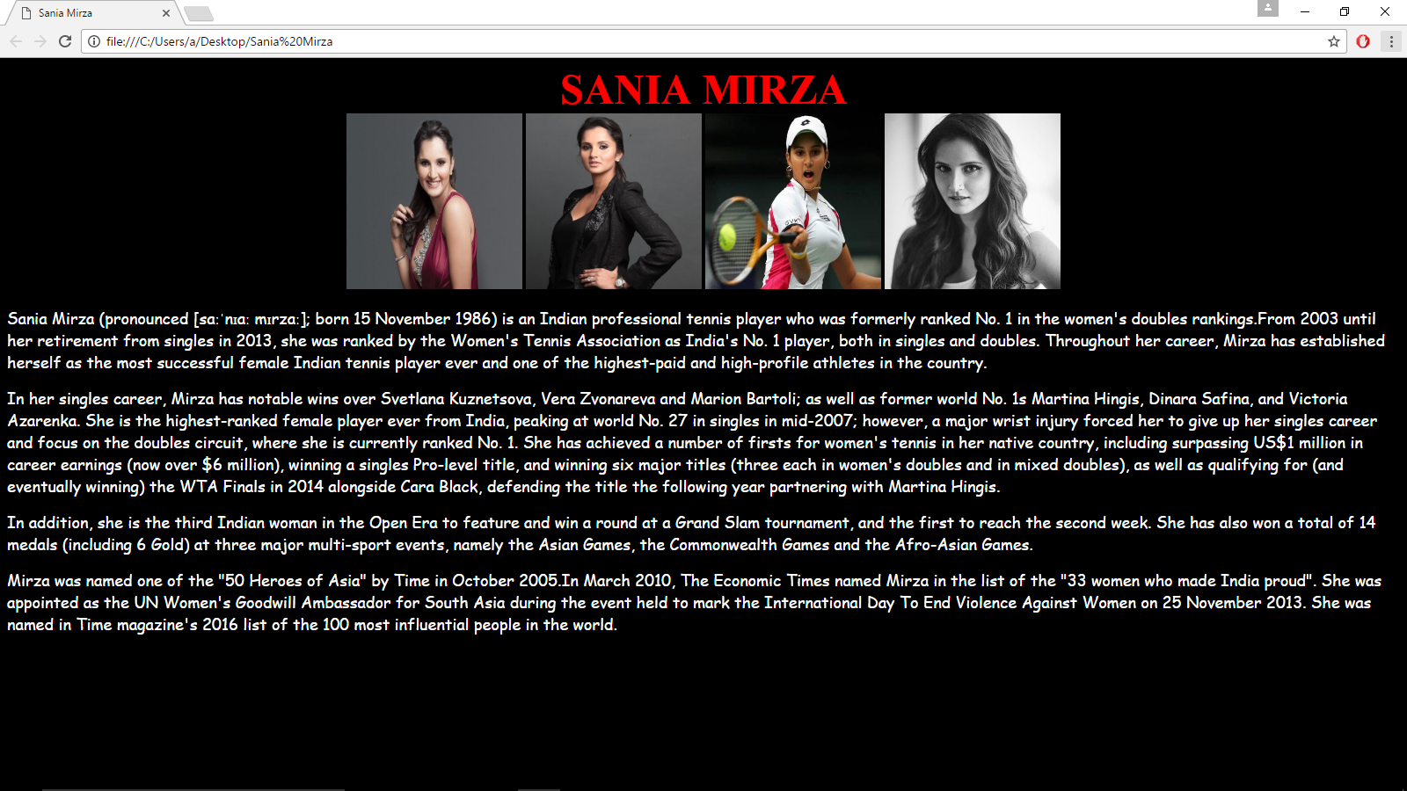

**EXPERIMENT – 2**

**AIM**

Design a webpage to demonstrate table (using basic HTML tags).

**SOURCE FILE**

<html>

<head>

<title>C, C++ AND JAVA</title>

</head>

<body>

<h1><font face="Verdana" color="Red"><center>DIFFERENCE BETWEEN C, C++ AND JAVA</center></font></h1>

<table border="1" cellspacing="4" cellpadding="4" width="100%">

<tr>

<th>ASPECT</th>

<th>C</th>

<th>C++</th>

<th>JAVA</th>

</tr>

<tr>

<th>Developed Year</th>

<td><center>1972</center></td>

<td><center>1979</center></td>

<td><center>1991</center></td>

</tr>

<tr>

<th>Developed By</th>

<td><center>Dennis Ritchie</center></td>

<td><center>BjarneStroustrup</center></td>

<td><center>James Gosling</center></td>

</tr>

<tr>

<th>Successor Of</th>

<td><center>BCPL</center></td>

<td><center>C</center></td>

<td><center>C(Syntax) and C++(Structure)</center></td>

</tr>

<tr>

<th>Paradigms</th>

<td><center>Procedural</center></td>

<td><center>Object Oriented</center></td>

<td><center>Object Oriented</center></td>

</tr>

<tr>

<th>Approach</th>

<td><center>Top Down Approach</center></td>

<td><center>Bottom Up Approach</center></td>

<td><center>Bottom Up Approach</center></td>

</tr>

<tr>

<th>Platform Dependency</th>

<td><center>Dependent</center></td>

<td><center>Dependent</center></td>

<td><center>Independent</center></td>

</tr>

<tr>

<th>Keywords</th>

<td><center>32</center></td>

<td><center>63</center></td>

<td><center>50</center></td>

</tr>

<tr>

<th>Datatypes: Structures,Unions</th>

<td><center>Supported</center></td>

<td><center>Supported</center></td>

<td><center>Not Supported</center></td>

</tr>

<tr>

<th>Pre-Processor Directives</th>

<td><center>Supported</center></td>

<td><center>Supported</center></td>

<td><center>Not Supported</center></td>

</tr>

<tr>

<th>Header Files</th>

<td><center>Supported</center></td>

<td><center>Supported</center></td>

<td><center>Uses Packages</center></td>

</tr>

<tr>

<th>Inheritance</th>

<td><center>No Inheritance</center></td>

<td><center>Supported</center></td>

<td><center>Multiple Inheritance Not Supported</center></td>

</tr>

<tr>

<th>Overloading</th>

<td><center>No Overloading</center></td>

<td><center>Supported</center></td>

<td><center>Operator Overloading Not Supported</center></td>

</tr>

<tr>

<th>Pointers</th>

<td><center>Supported</center></td>

<td><center>Supported</center></td>

<td><center>No Pointers</center></td>

</tr>

<tr>

<th>Code Translation</th>

<td><center>Compiled</center></td>

<td><center>Compiled</center></td>

<td><center>Interpreted</center></td>

</tr>

<tr>

<th>Storage Allocation</th>

<td><center>Uses calloc and malloc functions</center></td>

<td><center>Uses new and delete keywords</center></td>

<td><center>Uses Garbage Collector</center></td>

</tr>

<tr>

<th>Multi Threading</th>

<td><center>Not Supported</center></td>

<td><center>Not Supported</center></td>

<td><center>Supported</center></td>

</tr>

<tr>

<th>Interfaces</th>

<td><center>Not Supported</center></td>

<td><center>Not Supported</center></td>

<td><center>Supported</center></td>

</tr>

<tr>

<th>Exception Handling</th>

<td><center>No Exception Handling</center></td>

<td><center>Supported</center></td>

<td><center>Supported</center></td>

</tr>

<tr>

<th>Templates</th>

<td><center>Not Supported</center></td>

<td><center>Supported</center></td>

<td><center>Not Supported</center></td>

</tr>

<tr>

<th>Storage Class: Auto,Extern</th>

<td><center>Supported</center></td>

<td><center>Supported</center></td>

<td><center>Not Supported</center></td>

</tr>

<tr>

<th>Constructors And Destructors</th>

<td><center>Not Supported</center></td>

<td><center>Supported</center></td>

<td><center>Constructor Supported But Destructor Not Supported</center></td>

</tr>

<tr>

<th>Database Connectivity</th>

<td><center>Not Supported</center></td>

<td><center>Not Supported</center></td>

<td><center>Supported</center></td>

</tr>

</table>

</body>

<html>

**OUTPUT**

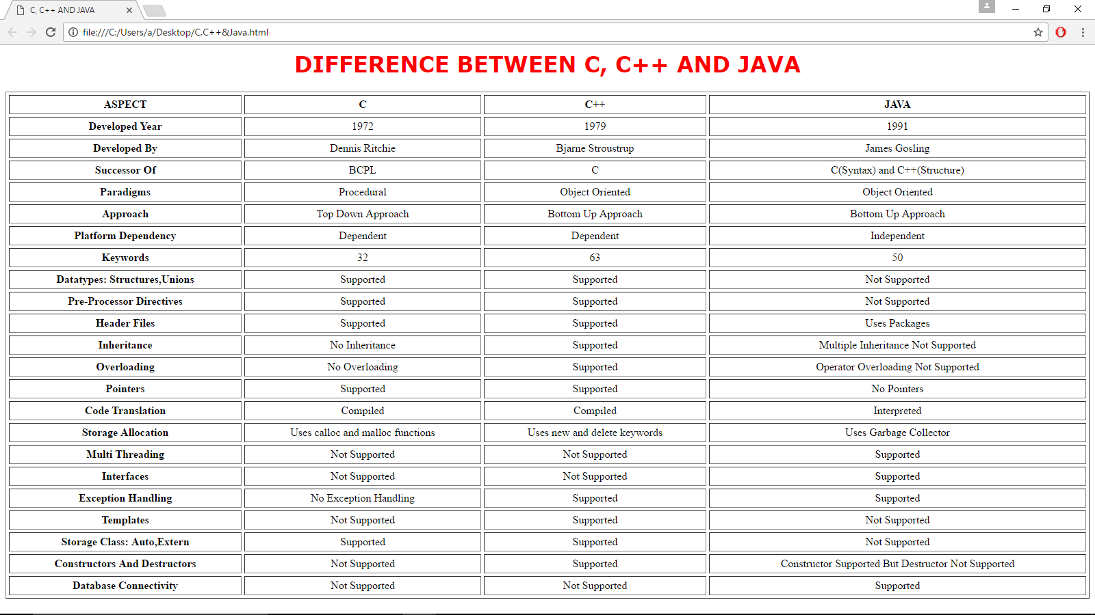

**EXPERIMENT – 3**

**AIM**

Design a webpage using forms (using basic HTML tags).

**SOURCE FILE**

<html>

<head>

<title>PERSONAL DETAILS</title>

</head>

<body>

<h2><font face="Verdana" color="Blue"><center>Please Enter Your Personal Details</center></font></h2>

<form method="post">

First name: <input type="text" name="first_name">

<br><br><br><br>

Last name: <input type="text" name="last_name">

<br><br><br><br>

User ID : <input type="text" name="user_id">

<br><br><br><br>

Password: <input type="password" name="password">

<br><br><br><br>

Address: <textarea rows="5" cols="50" name="description">

</textarea>

<br><br><br><br>

Gender: <input type="radio" name="gender" value="female"> Female

<input type="radio" name="gender" value="male"> Male

<br><br><br><br>

Subjects To Be Studied: <input type="checkbox" name="maths" value="on">Maths

<input type="checkbox" name="physics" value="on"> Physics

<br><br><br><br>

Nationality: <select name="dropdown">

<option value="Indian" selected>Indian</option>

<option value="NRI">NRI</option>

<option value="Others">Others</option>

</select>

<br><br><br><br>

<input type="submit" name="submit" value="Submit">

</body>

<html>

**OUTPUT**

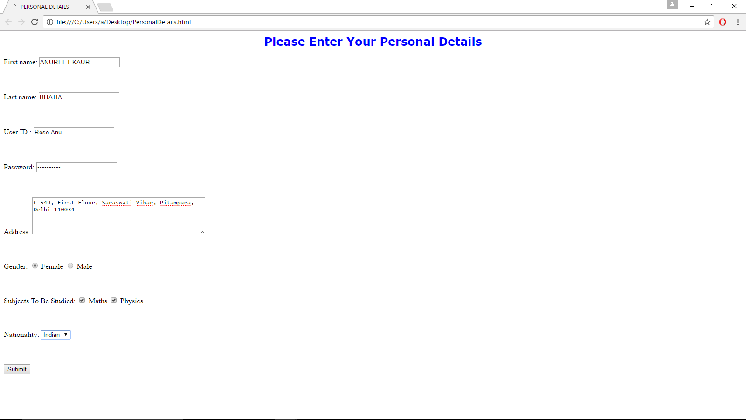

**EXPERIMENT – 4**

**AIM**

Design a static web page using external CSS.

**SOURCE FILE**

CSS1.html

<html>

<head>

<title>First CSS Doc</title>

<link rel="stylesheet" type="text/css" href="styles.css" />

</head>

<body>

<section id="page">

<header>

<hgroup>

<h1>MAIT</h1>

<h3>Maharaja Agrasen Institue Of Technology</h3>

</hgroup>

<nav class="clear">

<ul>

<li><a href="#article1">About Us</a></li>

<li><a href="#article2">Our Mission</a></li>

<li><a href="#article3">Departments</a></li>

</ul>

</nav>

</header>

<section id="articles">

<div class="line"></div>

<article id="article1">

<h2>About Us</h2>

<div class="line"></div>

<div class="articleBody clear">

<figure>

<img src="C:\Users\anureet kaur\Desktop\college\6_Sem\Web_Engineering\college.jpg" width="620" height="340">

</figure>

<p>

Maharaja Agrasen Institute of Technology (MAIT) is a private Engineering College, located in New Delhi, India. One of the reputed engineering colleges of India, MAIT has 10 departments (Five-Engineering, Four-Research and Three-Auxiliary). It is affiliated to the Guru Gobind Singh Indraprastha University, Delhi. It is among the top 5 engineering colleges in New Delhi.

</p>

<p>

MAIT has been ranked as the 9th best engineering college in India by the DataQuest Magaize for the year 2014-15. It has also been ranked at 70 among engineering colleges in India by the The Week-Hansa survey conducted by The Week magazine, and also the 27th best private engineering college in India by the same magazine. The college has been rated AAA+ by Careers 360 (Magazine) Top Engineering Colleges in India 2015. The alumni of the college are in prestigious Institutes such as Indian School Of Business(ISB) and companies Advance Micro Devices(AMD), Reckitt Benckiser & Nokia.

</p>

</div>

</article>

<section>

<footer>

<div class="line"></div>

</footer>

</section>

</section>

</section>

</body>

</html>

Style.css

*

{

margin:0;

padding:0;

}

header,footer,article,section,hgroup,nav,figure

{

display:block;

}

body

{

font-size:0.825em;

color:#fcfcfc;

background-color:#355664;

font-family:Arial, Helvetica, sans-serif;

}

a, a:visited

{

color:#0196e3;

text-decoration:none;

outline:none;

}

a:hover

{

text-decoration:underline;

}

img

{

border:none;

}

h1,h2,h3

{

font-family:"Myriad Pro","Helvetica Neue",Helvetica,Arial,Sans-Serif;

text-shadow:0 1px 1px black;

}

h1

{

font-size:3.5em;

padding:0.5em 0 0;

text-transform:uppercase;

}

h3

{

font-family:forte,"Myriad Pro","Helvetica Neue",Helvetica,Arial,Sans-Serif;

font-size:2em;

font-weight:normal;

margin:0 0 1em;

}

h2

{

font-size:2.2em;

font-weight:normal;

letter-spacing:0.01em;

text-transform:uppercase;

}

p

{

line-height:1.5em;

padding-bottom:1em;

}

.line

{

height:1px;

background-color:#24404c;

border-bottom:1px solid #416371;

margin:1em 0;

overflow:hidden;

}

article .line

{

background-color:#15242a;

border-bottom-color:#204656;

margin:1.3em 0;

}

footer .line

{

margin:2em 0;

}

nav

{

background-color:#f8f8f8;

padding:0 5px;

position:absolute;

right:0;

top:4em;

border:1px solid #FCFCFC;

}

nav ul li

{

display:inline;

}

nav ul li a,nav ul li a:visited

{

color:#565656;

display:block;

float:left;

font-size:1.25em;

font-weight:bold;

margin:5px 2px;

padding:7px 10px 4px;

text-shadow:0 1px 1px white;

text-transform:uppercase;

}

nav ul li a:hover

{

text-decoration:none;

background-color:#f0f0f0;

}

#page

{

width:960px;

margin:0 auto;

position:relative;

}

article

{

background-color:#213E4A;

margin:3em 0;

padding:20px;

text-shadow:0 2px 0 black;

}

figure

{

border:3px solid #142830;

float:right;

height:300px;

margin-left:15px;

overflow:hidden;

width:500px;

}

figure img

{

margin-left:-60px;

}

footer

{

margin-bottom:30px;

text-align:center;

font-size:0.825em;

}

footer p

{

margin-bottom:-2.5em;

position:relative;

}

**OUTPUT**

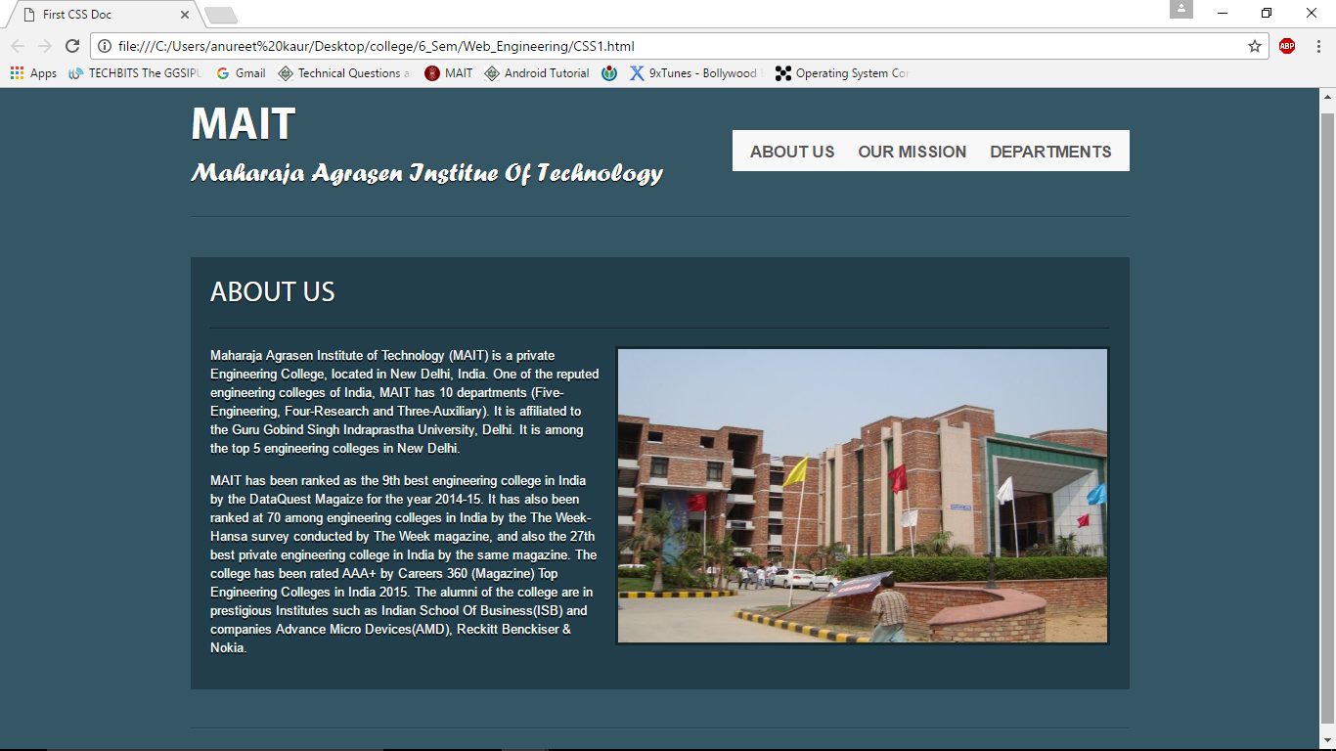

**EXPERIMENT – 5**

**AIM**

Add style to a web page using CSS.

**SOURCE FILE**

<html>

<head>

<title>WE ARE COMING SOON</title>

</head>

<body>

<div style="background:url(pattern.jpg)">

<h1 style="margin-top:7px;font-family:'Lobster',cursive;font-size:38px;line-height:42px;font-weight:400;color:#555;"><a href="index.html" style="color:#555;">Anureet Kaur Bhatia</a><span style="color:#e75967;">.</span></h1>

<p style="font-size:18px;line-height:22px;text-align:right;margin-top:18px;">Tel: <span style="font-size:18px;line-height:22px;margin-top:18px;text-align:right;color:#888;">0039 123 45 789</span> | Skype: <span style="font-size:18px;line-height:22px;margin-top:18px;text-align:right;color:#888;">info@domain.it</span></p>

</div>

<div style="margin:0 auto;text-align:center;color:#fff;padding:55px 0 60px 0;background:url(1.jpg);">

<h2 style="font-size:40px;line-height:44px;font-weight:700;text-transform:uppercase;text-shadow:0 1px 7px rgba(0,0,0,.2);">We're Coming Soon</h2>

<p style="margin-top:20px;font-size:18px;line-height:36px;text-shadow:0 1px 7px rgba(0,0,0,.2);">We are working very hard on the new version of our site. It will bring a lot of new features. Stay tuned!</p>

</div>

<div style="margin-top:30px;text-align:center;background:url(pattern.jpg)">

<h3 style="font-size:32px;font-weight:400;color:#4d4d4d;line-height:40px;text-transform:uppercase;text-shadow:1px 2px 1px #fff;">Subscribe to our newsletter</h3>

<form method="post">

<p style="font-size:18px;font-weight:400;line-height:36px;">Email address</p>

<input type="text" name="email" placeholder="Enter your email..." style="width:310px;height:46px;margin:0;padding:0 10px;background:#fff;font-family:'Lato',sans-serif;font-size:18px;line-height:46px;color:#888;border:0;">

<br><br>

<button type="submit" class="btn" style="width:130px;height:46px;margin:0;padding:0;background:#e75967;border:0;font-family:'Lato',sans-serif;font-size:18px;line-height:46px;color:#fff;text-transform:uppercase;text-shadow:1px 1px 1px rgba(0,0,0,.3);">Subscribe</button>

</form>

</div>

</body>

</html>

**OUTPUT**

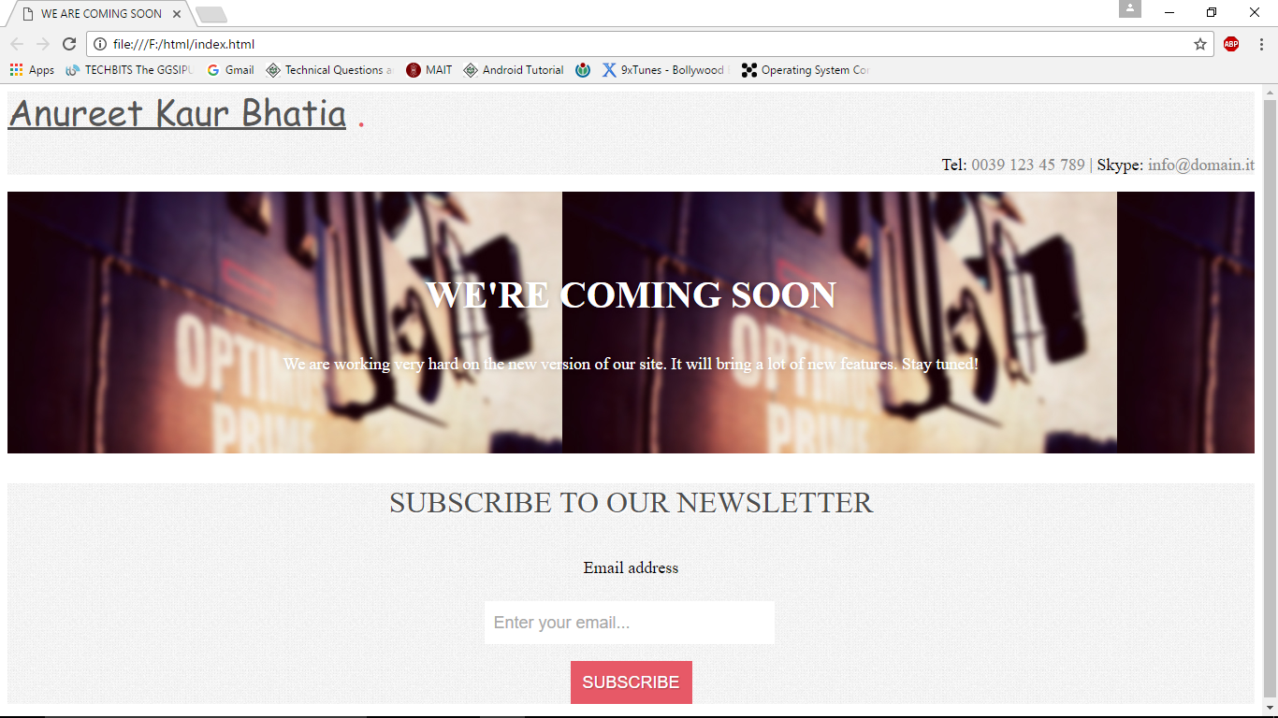

**EXPERIMENT – 6**

**AIM**

Design a static web page using internal CSS.

**SOURCE FILE**

<html>

<head>

<title>LOGIN</title>

<style type = "text/css" media = "all">

html,body,div,h1,h2,h3,h4,h5,h6,p,footer, header

{

display: block;

}

body

{

text-align: center;

font-family: 'Oleo Script', cursive;

}

.center-container

{

padding: 0em;

background: rgba(0, 0, 0, 0.42)

}

.header-w3l

{

padding-top: 2em;

}

.header-w3l h1

{

font-size:3em;

color:green;

letter-spacing: 4px;

font-weight: 500;

text-transform: uppercase;

}

.main-content-agile

{

margin: 7em 0em 3em;

}

.wthree-pro h2

{

font-size: 1.5em;

color: green;

letter-spacing: 1px;

margin-top: 0.3em;

margin-bottom: 2em;

font-weight: 400;

}

.sub-main-w3 input[type="email"], .sub-main-w3 input[type="password"]

{

outline: none;

font-size: 1em;

padding: 1em 3em 1em 1em;

border: none;

margin-bottom: 0.3em;

background: none;

border: 1px solid #eee;

width: 82%;

color: #fff;

font-weight: 400;

font-family: 'Oleo Script', cursive;

letter-spacing: 1px;

}

.sub-main-w3

{

position: relative;

width: 23%;

margin: 0 auto;

}

.sub-w3l h6 a

{

font-size: 1em;

color: #fff;

letter-spacing: 2px;

text-align: right;

display: inherit;

}

.sub-w3l

{

margin-top: 2em;

}

.sub-main-w3 input[type="submit"]

{

color: white;

background: #2baf2b;

border: none;

padding: 8px 0px;

outline: none;

width: 38%;

font-size: 1.1em;

cursor: pointer;

letter-spacing: 2px;

font-weight: 400;

font-family: 'Oleo Script', cursive;

transition: 0.5s all;

}

.sub-main-w3 input[type="submit"]:hover

{

background: #fff;

color: black;

transition:0.5s all;

}

.footer

{

padding: 0.5cm 0 3em;

}

.footer p

{

font-size: 1em;

color: red;

letter-spacing: 2px;

}

</style>

</head>

<body>

<div class="header-w3l">

<h1>Classic Login Form</h1>

</div>

<div class="main-content-agile">

<div class="sub-main-w3">

<div class="wthree-pro">

<h2>Login Here</h2>

</div>

<form action="#" method="post">

<input placeholder="Username or E-mail" name="Name" class="user" type="email" required="">

<input placeholder="Password" name="Password" class="pass" type="password" required="">

<div class="sub-w3l">

<h6><a href="#">Forgot Password?</a></h6>

<div class="right-w3l">

<input type="submit" value="Login">

</div>

</div>

</form>

</div>

</div>

<div class="footer">

<p>Made By - Anureet Kaur Bhatia</p>

</div>

</div>

</div>

</body>

</html>

**OUTPUT**

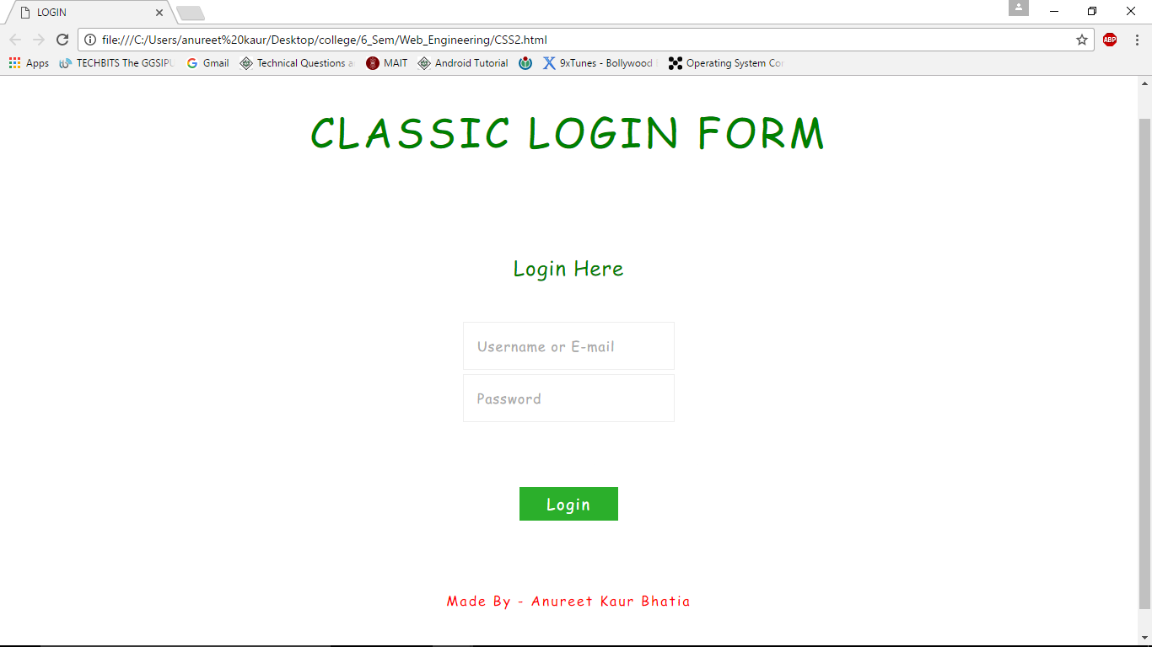

**EXPERIMENT – 7**

**AIM**

Design a webpage that implements a simple interest calculator using JavaScript.

**SOURCE FILE**

<html>

<head>

<title>SI Calculator</title>

<script>

function calculate()

{

p = document.getElementById("p").value;

n = document.getElementById("n").value;

r = document.getElementById("r").value;

result = document.getElementById("result");

result.innerHTML = "The interest is " + (p*n*r/100);

}

</script>

<style type = "text/css" media = "all">

.footer

{

padding: 0.5cm 0 3em;

}

.footer p

{

font-size: 1em;

color: red;

letter-spacing: 2px;

}

</style>

</head>

<body>

<h1>Simple Interest Calculation</h1>

<br><br><br>

Amount: <input id="p"><br><br><br><br><br>

Rate: <input id="r"><br><br><br><br><br>

No. of Years: <input id="n"><br><br><br><br><br>

<button onclick="calculate()">Calculate</button><br><br><br><br>

<p id="result"></p>

<div class="footer">

<p>Made By - Anureet Kaur Bhatia</p>

</div>

</body>

</html>

**OUTPUT**

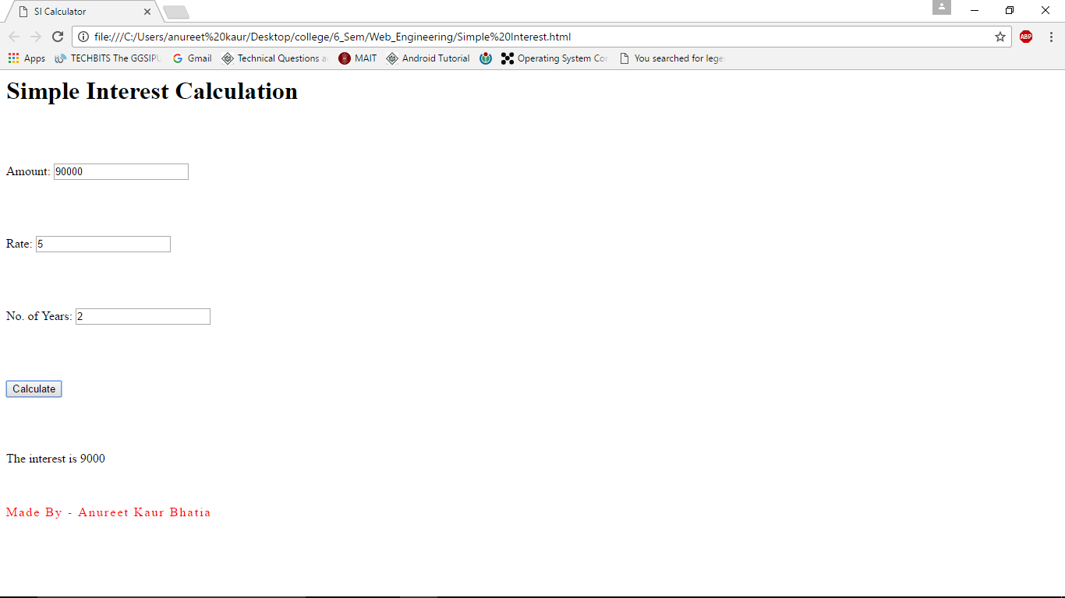

**EXPERIMENT – 8**

**AIM**

Design a webpage to display current date and time using JavaScript.

**SOURCE FILE**

<html>

<head>

<title>Current DateTime</title>

<script>

function show()

{

var d = new Date();

document.getElementById("demo").innerHTML = d;

}

</script>

<style type = "text/css" media = "all">

.footer

{

padding: 0.5cm 0 3em;

}

.footer p

{

font-size: 1em;

color: red;

letter-spacing: 2px;

}

</style>

</head>

<body>

<button onclick="show()">Show Current Date And Time</button><br><br><br><br>

<p id="demo"></p>

<div class="footer">

<p>Made By - Anureet Kaur Bhatia</p>

</div>

</body>

</html>

**OUTPUT**

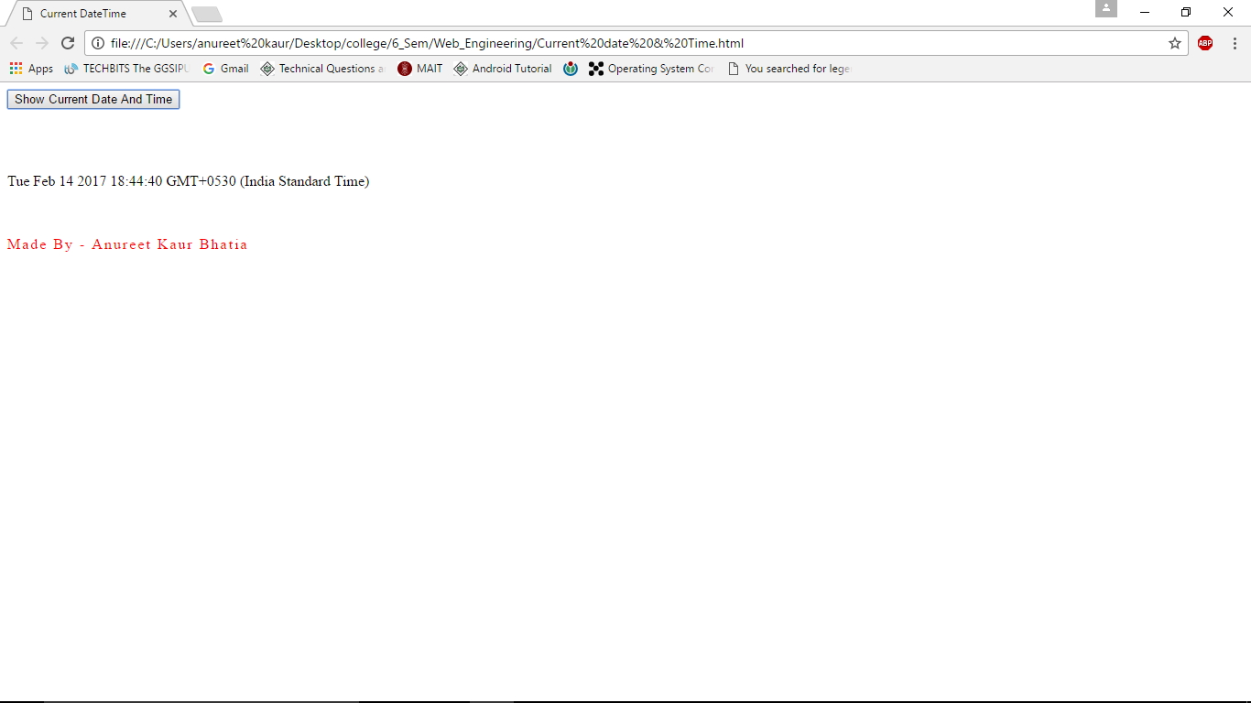

**EXPERIMENT – 9**

**AIM**

Design a simple form and validate textbox for email and alphabetic characters using JavaScript.

**SOURCE FILE**

<html>

<head>

<title> Form Validation:Name And Email </title>

<script>

function formValidation()

{

var firstname = document.getElementById('firstname');

var email = document.getElementById('email');

inputAlphabet(firstname, "* For your name please use alphabets only *");

emailValidation(email, "* Please enter a valid email address *")

}

function inputAlphabet(inputtext, alertMsg)

{

var alphaExp = /^[a-zA-Z]+$/;

if(inputtext.value.match(alphaExp))

{

document.getElementById('p1').innerText = "* Entered Name Is Valid *";

}

else{

document.getElementById('p1').innerText = alertMsg;

}

}

function emailValidation(inputtext, alertMsg)

{

var emailExp = /^[\w\-\.\+]+\@[a-zA-Z0-9\.\-]+\.[a-zA-z0-9]{2,4}$/;

if(inputtext.value.match(emailExp))

{

document.getElementById('p3').innerText = "* Entered Email Is Valid *";

}

else

{

document.getElementById('p3').innerText = alertMsg;

}

}

</script>

<style type = "text/css" media = "all">

.footer

{

padding: 0.5cm 0 3em;

}

.footer p

{

font-size: 1em;

color: red;

letter-spacing: 2px;

}

</style>

</head>

<body>

<h2>JavaScript Form Validation</h2>

<br><br><br><br>

First Name:

<input type='text' id='firstname'><br><br><br><br>

<p id="p1"></p>

<br><br><br><br>

Email:

<input type='text' id='email'><br><br><br><br>

<p id="p3"></p>

<br><br><br><br>

<button onclick="formValidation()">Validate Form</button><br><br><br><br>

<div class="footer">

<p>Made By - Anureet Kaur Bhatia</p>

</div>

</body>

</html>

**OUTPUT**

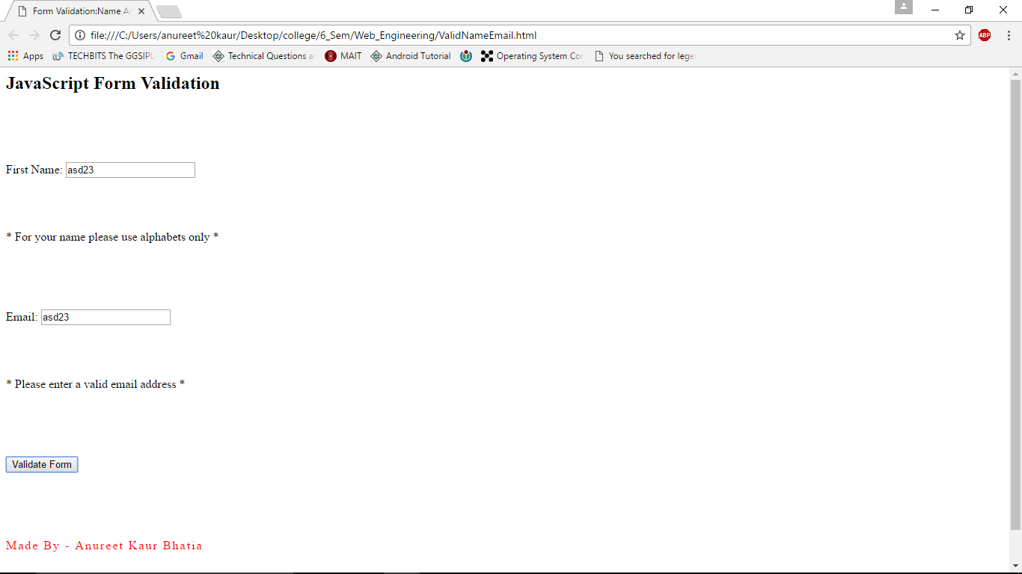

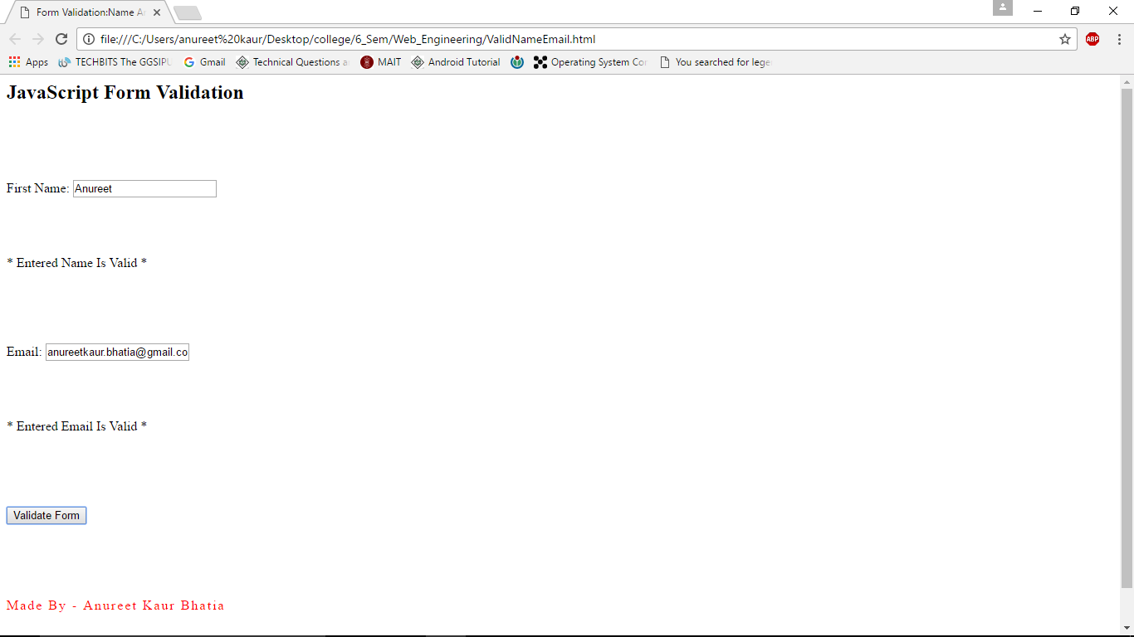

**EXPERIMENT – 10**

**AIM**

Design a simple form and validate for password and phone number using JavaScript.

**SOURCE FILE**

<html>

<head>

<title> Form Validation:Password And Phone </title>

<script>

function formValidation()

{

var password = document.getElementById('password');

var number = document.getElementById('number');

inputPassword(password, "* For your password please use alphabets and numbers only *");

numberValidation(number, "* Please enter a valid phone number *")

}

function inputPassword(inputtext, alertMsg)

{

var alphaExp = /^[0-9a-zA-Z]+$/;

if(inputtext.value.match(alphaExp))

{

document.getElementById('p1').innerText = "* Entered Password Is Valid *";

}

else{

document.getElementById('p1').innerText = alertMsg;

}

}

function numberValidation(inputtext, alertMsg)

{

var numericExpression = /^[0-9]+$/;

if(inputtext.value.match(numericExpression)&&inputtext.value.length==10)

{

document.getElementById('p2').innerText = "* Entered Number Is Valid *";

}

else

{

document.getElementById('p2').innerText = alertMsg;

}

}

</script>

<style type = "text/css" media = "all">

.footer

{

padding: 0.5cm 0 3em;

}

.footer p

{

font-size: 1em;

color: red;

letter-spacing: 2px;

}

</style>

</head>

<body>

<h2>JavaScript Form Validation</h2>

<br><br><br><br>

Password:

<input type='text' id='password'><br><br><br><br>

<p id="p1"></p>

<br><br><br><br>

Phone Number:

<input type='text' id='number'><br><br><br><br>

<p id="p2"></p>

<br><br><br><br>

<button onclick="formValidation()">Validate Form</button><br><br><br><br>

<div class="footer">

<p>Made By - Anureet Kaur Bhatia</p>

</div>

</body>

</html>

**OUTPUT**

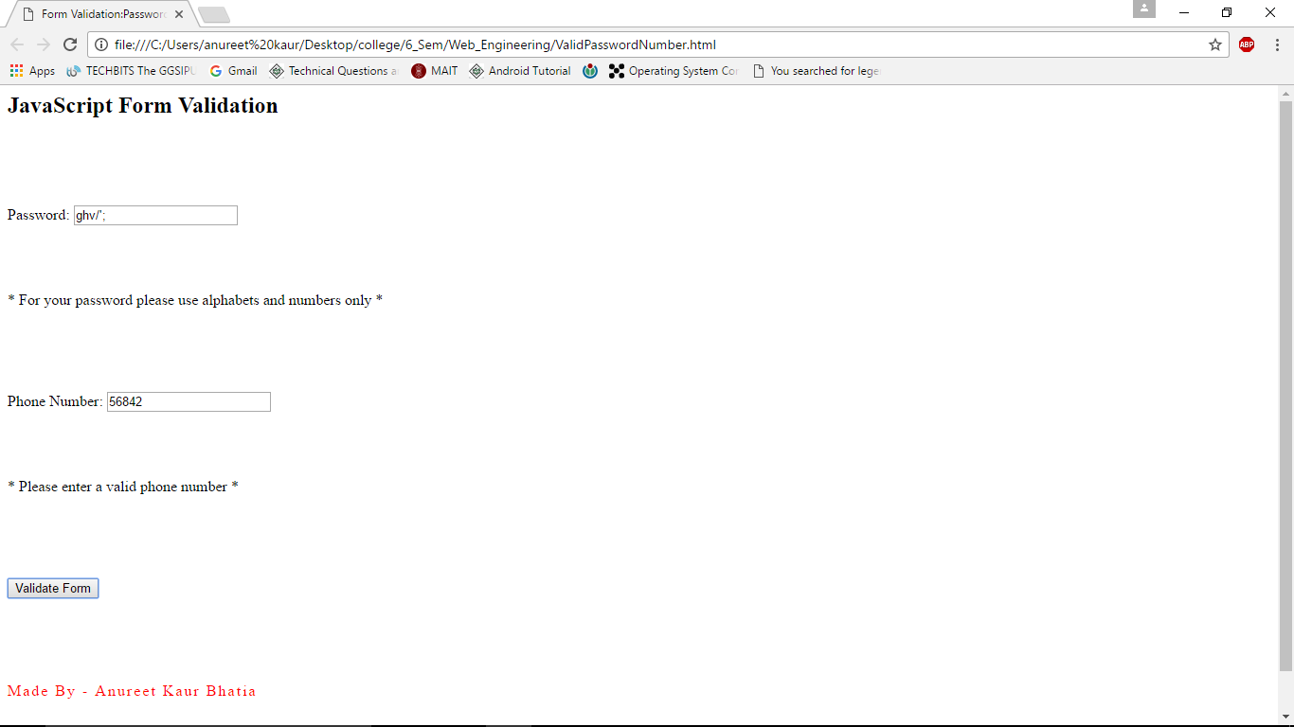

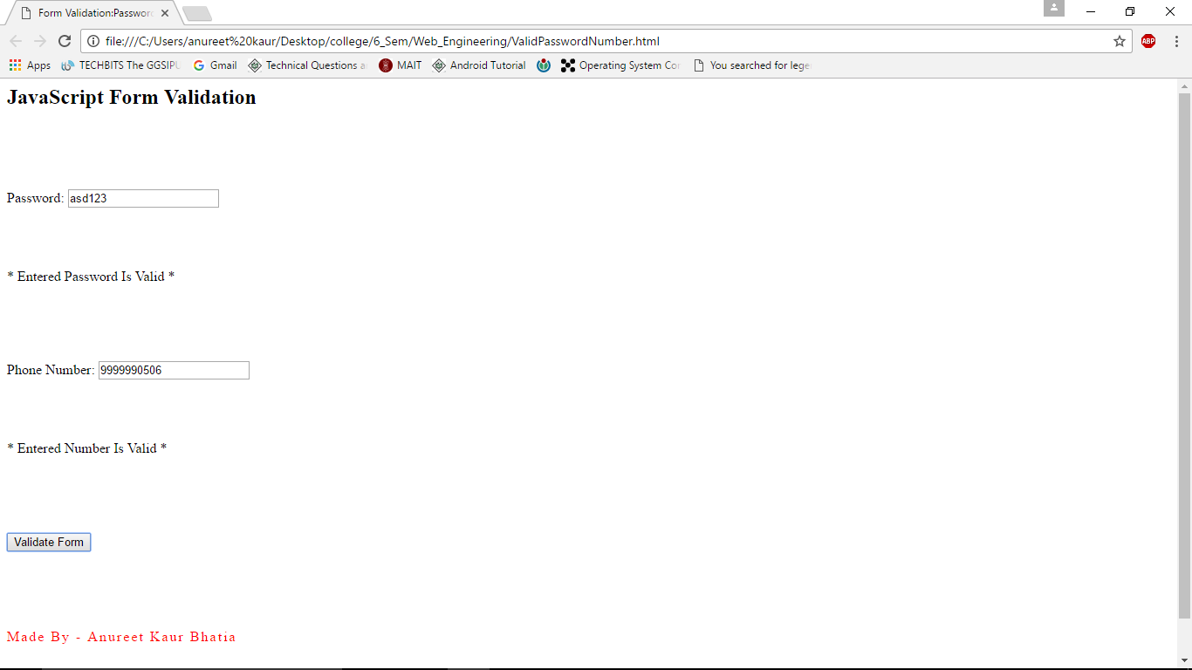

**EXPERIMENT – 11**

**AIM**

Design a webpage that implements a simple calculator using JavaScript.

**SOURCE FILE**

<html>

<head>

<title>Simple Calculator</title>

<script>

function add()

{

p = parseInt(document.getElementById("num1").value);

n = parseInt(document.getElementById("num2").value);

result = document.getElementById("result");

result.innerHTML = "The sum is " + (p+n);

}

function sub()

{

p = parseInt(document.getElementById("num1").value);

n = parseInt(document.getElementById("num2").value);

result = document.getElementById("result");

result.innerHTML = "The difference is " + (p-n);

}

functionmul()

{

p = parseInt(document.getElementById("num1").value);

n = parseInt(document.getElementById("num2").value);

result = document.getElementById("result");

result.innerHTML = "The product is " + (p*n);

}

functiondivi()

{

p = parseInt(document.getElementById("num1").value);

n = parseInt(document.getElementById("num2").value);

result = document.getElementById("result");

result.innerHTML = "The quotient is " + (p/n);

}

function exponent()

{

p = parseInt(document.getElementById("num1").value);

result = document.getElementById("result");

result.innerHTML = "e raised to the power of First Number is " + (Math.exp(p));

}

function cosine()

{

p = parseInt(document.getElementById("num1").value);

result = document.getElementById("result");

result.innerHTML = "The cos of given angle is " + (Math.cos(p));

}

function sine()

{

p = parseInt(document.getElementById("num1").value);

result = document.getElementById("result");

result.innerHTML = "The sin of given angle is " + (Math.sin(p));

}

function tangent()

{

p = parseInt(document.getElementById("num1").value);

result = document.getElementById("result");

result.innerHTML = "The tan of given angle is " + (Math.tan(p));

}

function power()

{

p = parseInt(document.getElementById("num1").value);

n = parseInt(document.getElementById("num2").value);

result = document.getElementById("result");

result.innerHTML = "First Number raised to the power of Second Number is " + (Math.pow(p,n));

}

functionsquareroot()

{

p = parseInt(document.getElementById("num1").value);

result = document.getElementById("result");

result.innerHTML = "The square root of given number is " + (Math.sqrt(p));

}

function loge()

{

p = parseInt(document.getElementById("num1").value);

result = document.getElementById("result");

result.innerHTML = "The natural log of given number is " + (Math.log(p));

}

</script>

<style type = "text/css" media = "all">

.footer

{

padding: 0.5cm 0 3em;

}

.footer p

{

font-size: 1em;

color: red;

letter-spacing: 2px;

}

</style>

</head>

<body>

<h1>Simple Calculator</h1>

<br>

<p>***For Sine,Cosine and Tan Enter Angle In Radians***</p>

<br>

First Number: <input id="num1"><br><br>

Second Number: <input id="num2"><br><br>

<table border="3">

<tr>

<td><button onclick="add()">ADD +</button></td>

<td><button onclick="sub()">SUBTRACT -</button></td>

</tr>

<tr>

<td><button onclick="mul()">MULTIPLY *</button></td>

<td><button onclick="divi()">DIVIDE /</button></td>

</tr>

<tr>

<td><button onclick="exponent()">e^x</button></td>

<td><button onclick="cosine()">COSINE</button></td>

</tr>

<tr>

<td><button onclick="sine()">SINE</button></td>

<td><button onclick="tangent()">TAN</button></td>

</tr>

<tr>

<td><button onclick="power()">X^Y</button></td>

<td><button onclick="squareroot()">SQRT</button></td>

</tr>

<tr>

<td><button onclick="loge()">LOG(base e)</button></td>

<td></td>

</tr>

</table>

<br><br><br>

<p id="result"></p>

<div class="footer">

<p>Made By - Anureet Kaur Bhatia</p>

</div>

</body>

</html>

**OUTPUT**

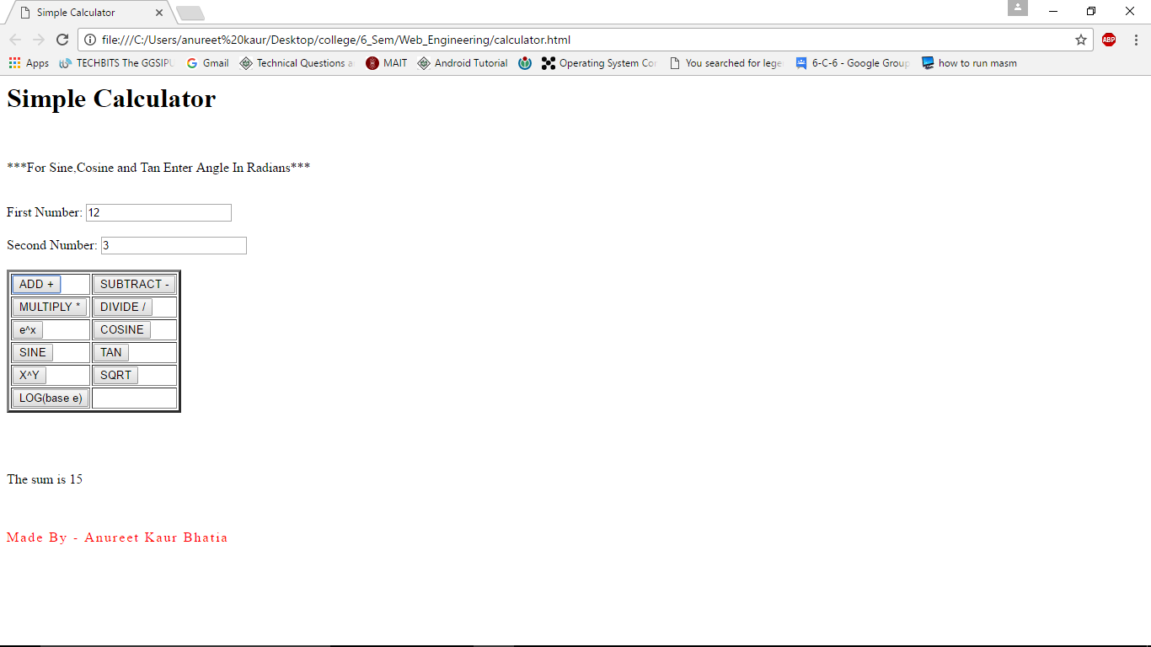

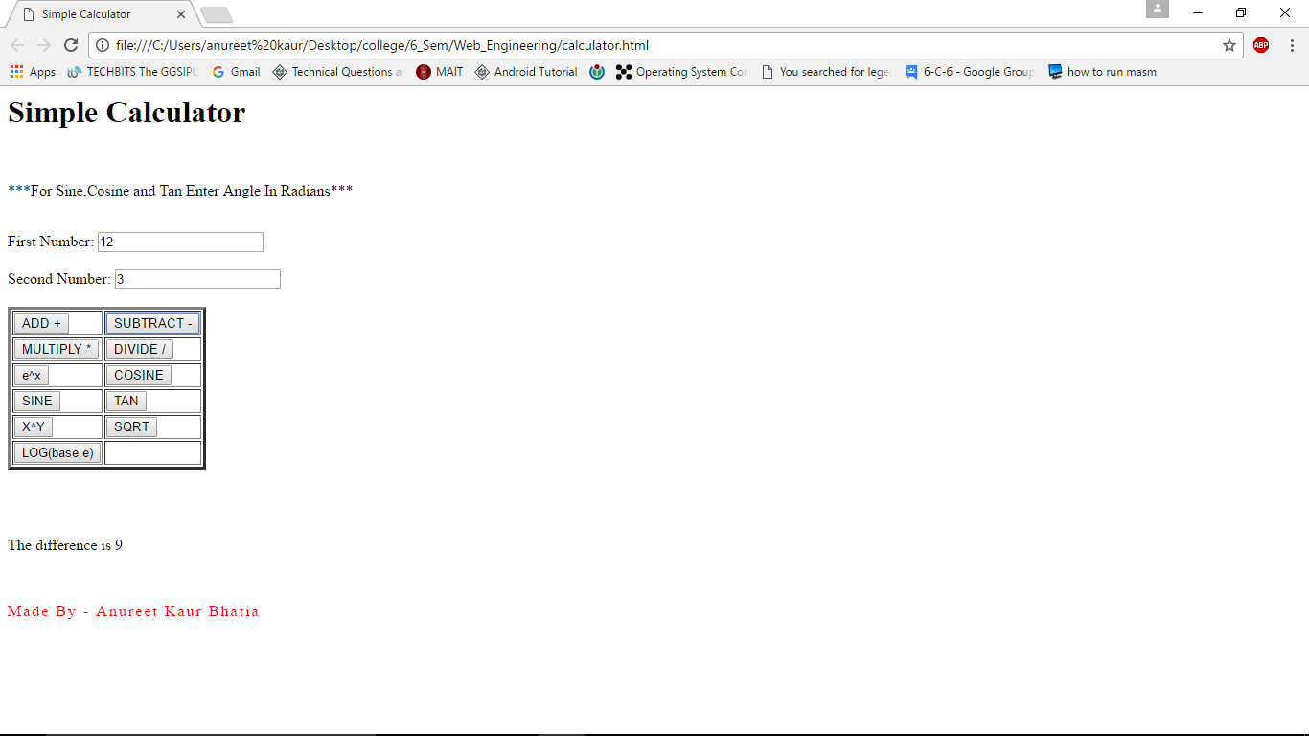

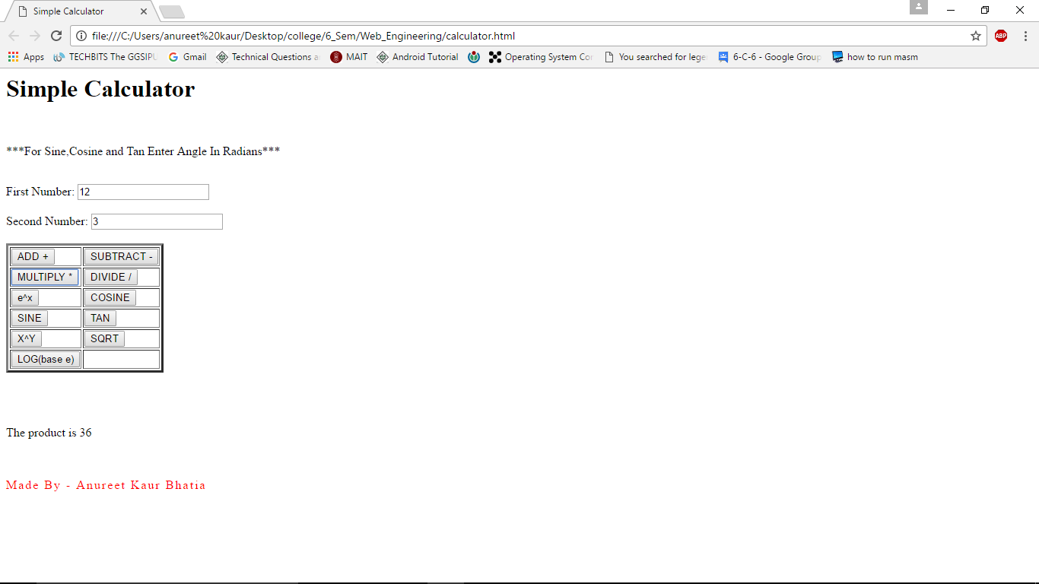

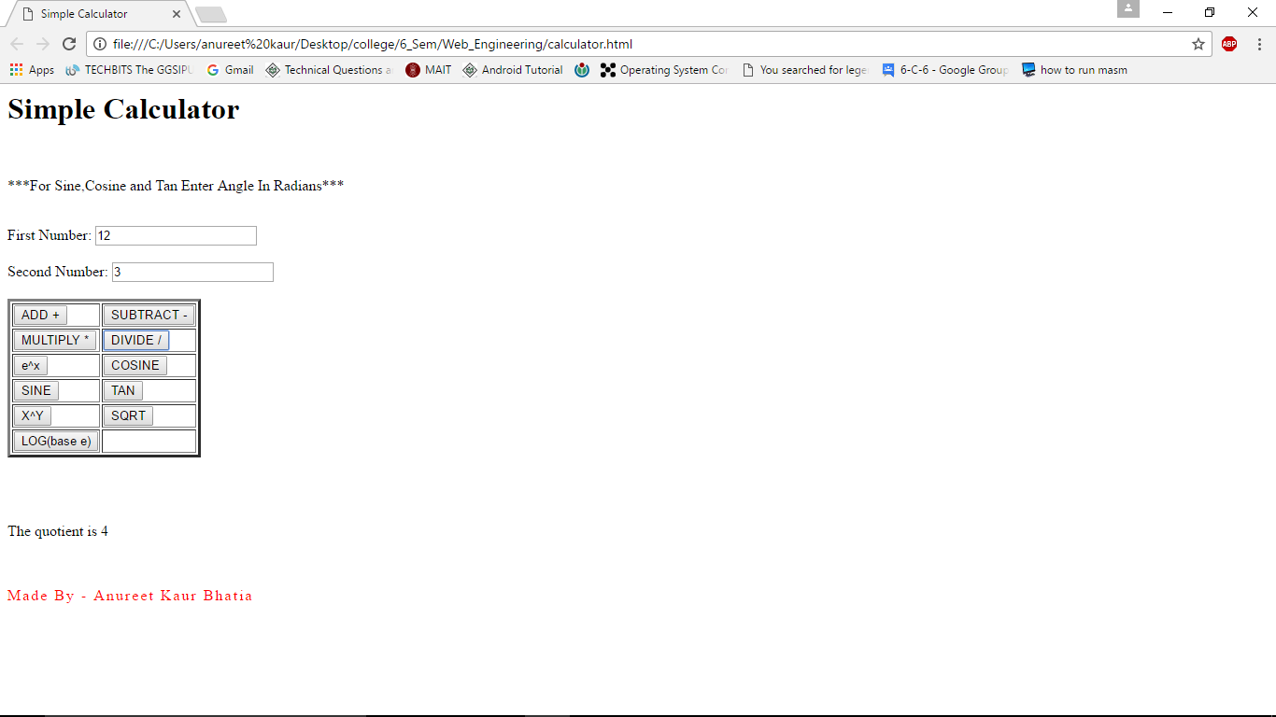

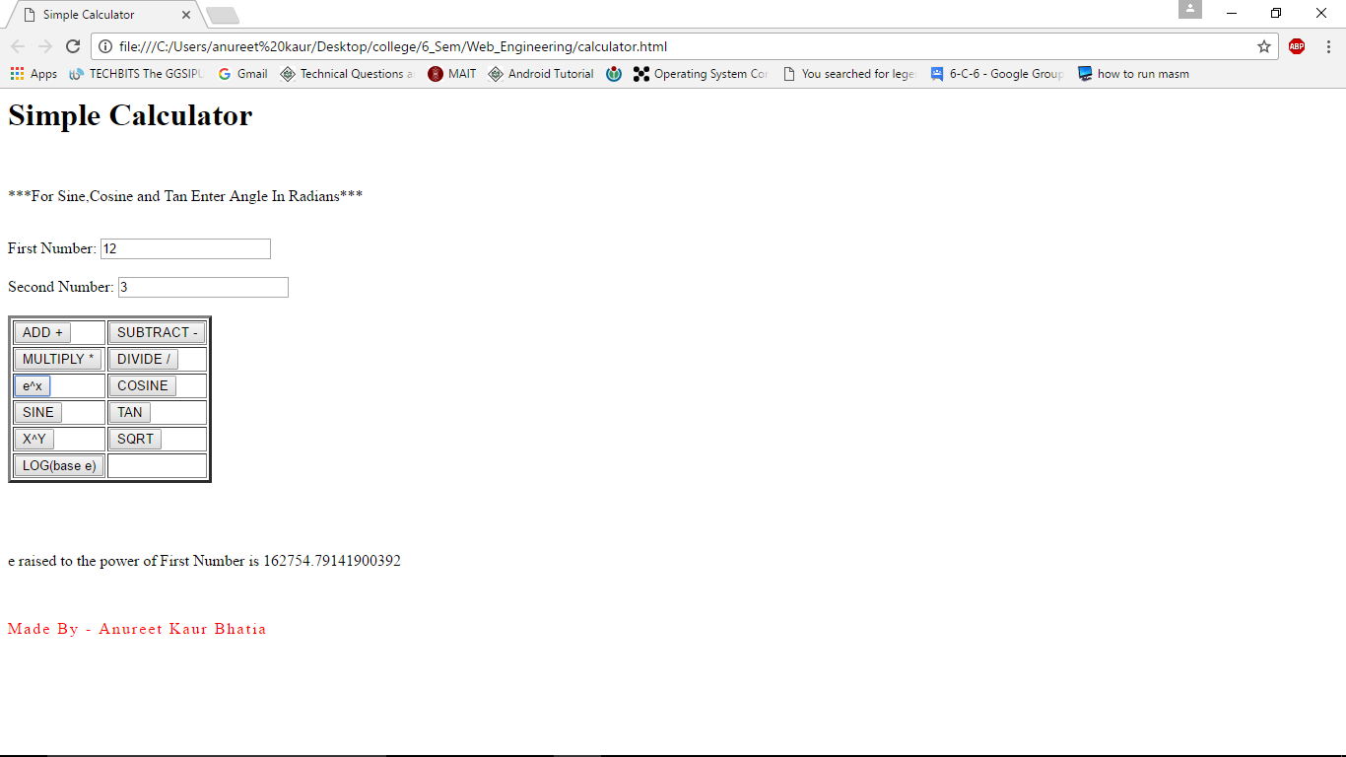

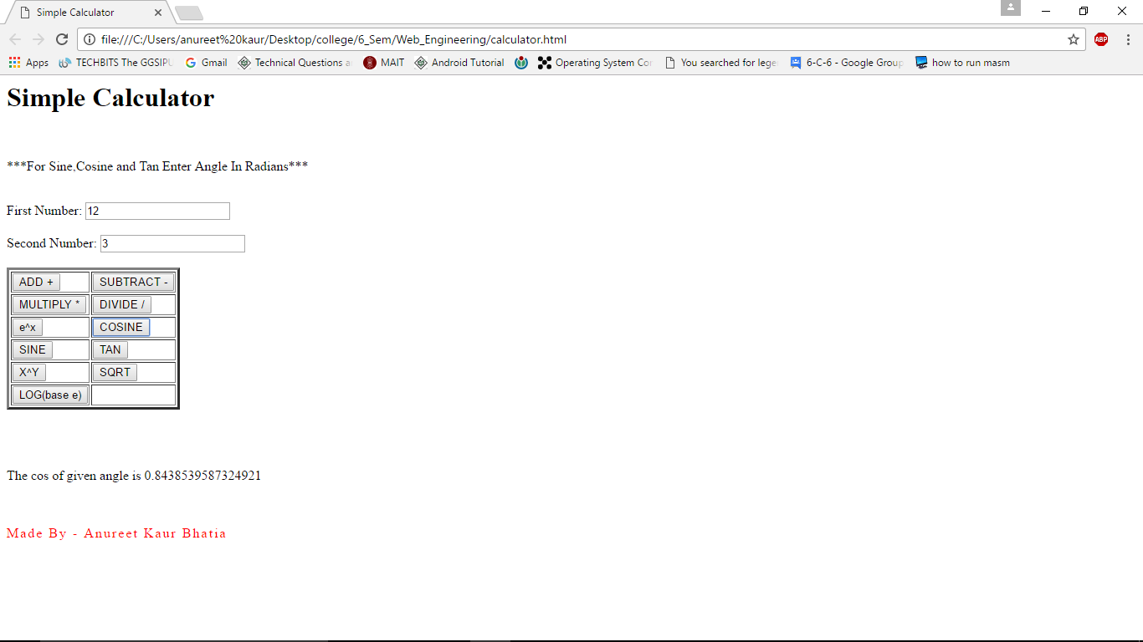

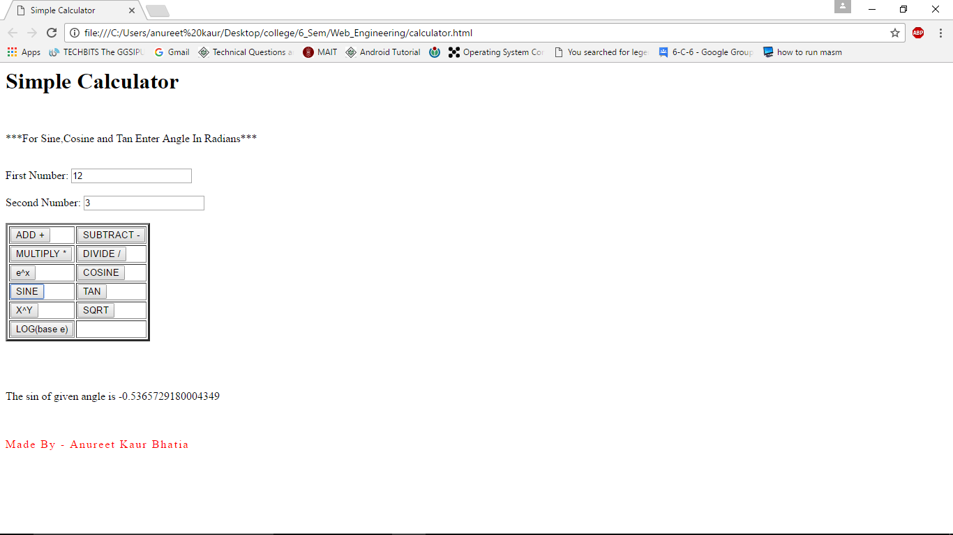

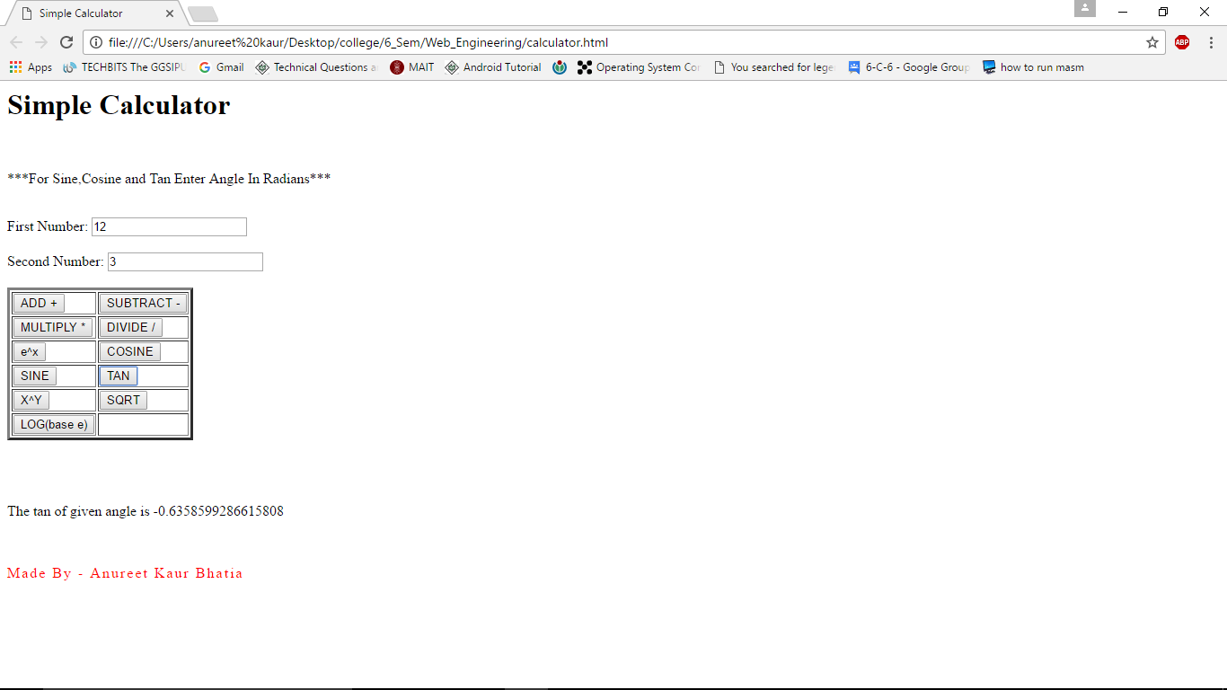

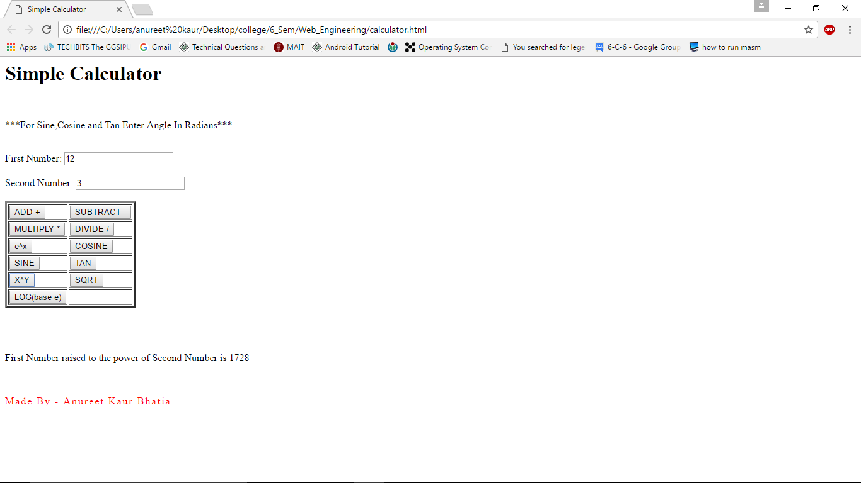

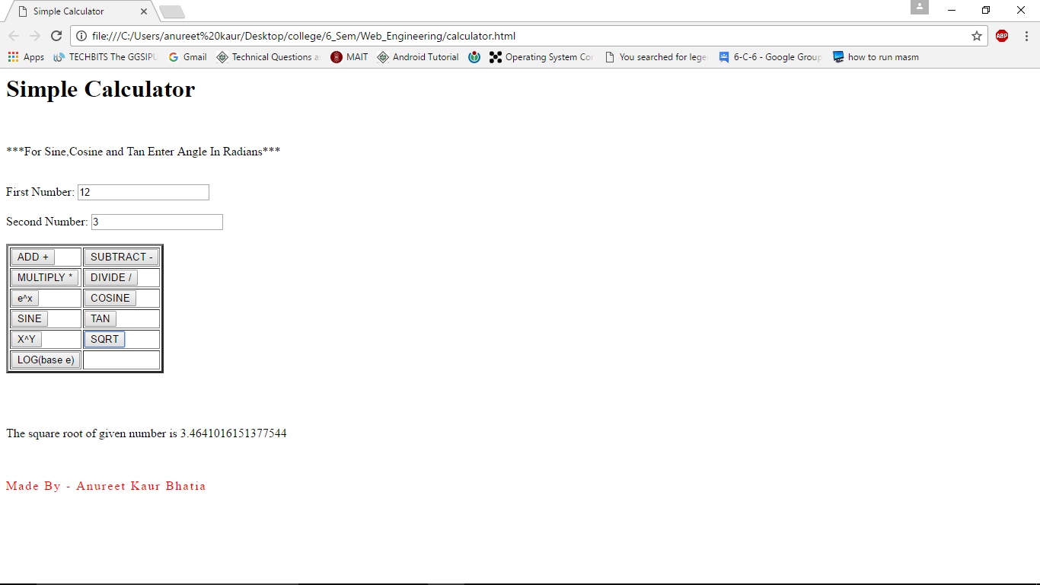

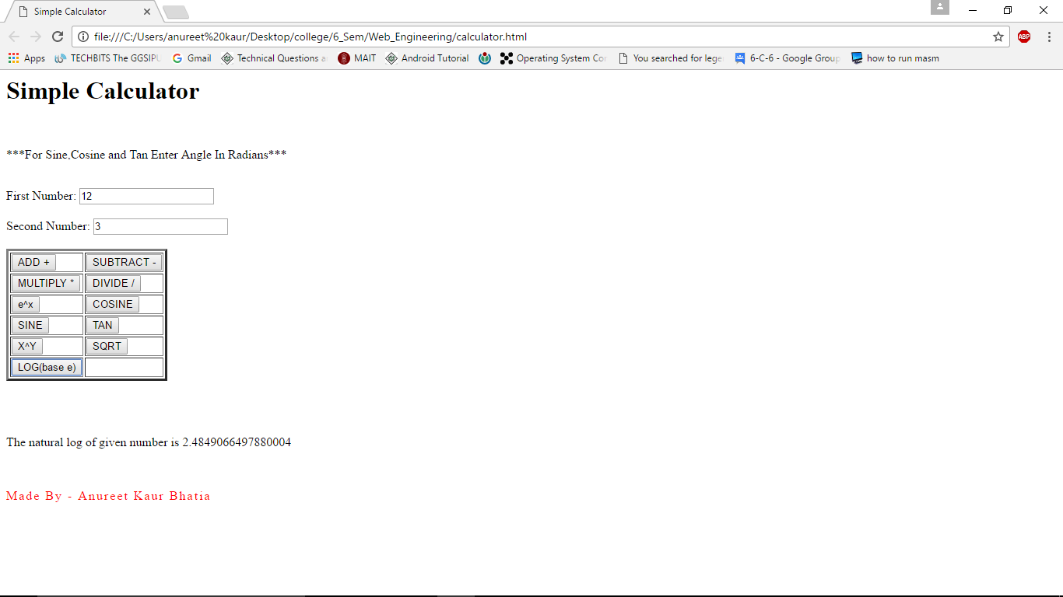

**EXPERIMENT – 12**

**AIM**

Design a CD Catalog using XML.

**SOURCE FILE**

<?xml version="1.0" encoding="UTF-8"?>

<CATALOG>

<CD>

<TITLE>Up All Night</TITLE>

<ARTIST>One Direction</ARTIST>

<LABEL>Syco, Columbia</LABEL>

<YEAR>2011</YEAR>

</CD>

<CD>

<TITLE>Take Me Home</TITLE>

<ARTIST>One Direction</ARTIST>

<LABEL>Syco, Columbia</LABEL>

<YEAR>2012</YEAR>

</CD>

<CD>

<TITLE>Midnight Memories</TITLE>

<ARTIST>One Direction</ARTIST>

<LABEL>Syco, Columbia</LABEL>

<YEAR>2013</YEAR>

</CD>

<CD>

<TITLE>Four</TITLE>

<ARTIST>One Direction</ARTIST>

<LABEL>Syco, Columbia</LABEL>

<YEAR>2014</YEAR>

</CD>

<CD>

<TITLE>Made In The A.M.</TITLE>

<ARTIST>One Direction</ARTIST>

<LABEL>Syco, Columbia</LABEL>

<YEAR>2015</YEAR>

</CD>

<CD>

<TITLE>Taylor Swift</TITLE>

<ARTIST>Taylor Swift</ARTIST>

<LABEL>Big Machine</LABEL>

<YEAR>2006</YEAR>

</CD>

<CD>

<TITLE>Fearless</TITLE>

<ARTIST>Taylor Swift</ARTIST>

<LABEL>Big Machine</LABEL>

<YEAR>2008</YEAR>

</CD>

<CD>

<TITLE>Speak Now</TITLE>

<ARTIST>Taylor Swift</ARTIST>

<LABEL>Big Machine</LABEL>

<YEAR>2010</YEAR>

</CD>

<CD>

<TITLE>Red</TITLE>

<ARTIST>Taylor Swift</ARTIST>

<LABEL>Big Machine</LABEL>

<YEAR>2012</YEAR>

</CD>

<CD>

<TITLE>1989</TITLE>

<ARTIST>Taylor Swift</ARTIST>

<LABEL>Big Machine</LABEL>

<YEAR>2014</YEAR>

</CD>

<CD>

<TITLE>Lights</TITLE>

<ARTIST>Ellie Goulding</ARTIST>

<LABEL>Big Machine</LABEL>

<YEAR>2014</YEAR>

</CD>

<CD>

<TITLE>Halycon</TITLE>

<ARTIST>Ellie Goulding</ARTIST>

<LABEL>Big Machine</LABEL>

<YEAR>2014</YEAR>

</CD>

<CD>

<TITLE>Delirium</TITLE>

<ARTIST>Ellie Goulding</ARTIST>

<LABEL>Big Machine</LABEL>

<YEAR>2014</YEAR>

</CD>

<CD>

<TITLE>Kiss And Tell</TITLE>

<ARTIST>Selena Gomez and The Scene</ARTIST>

<LABEL>Hollywood</LABEL>

<YEAR>2009</YEAR>

</CD>

<CD>

<TITLE>A Year Without Rain</TITLE>

<ARTIST>Selena Gomez and The Scene</ARTIST>

<LABEL>Hollywood</LABEL>

<YEAR>2010</YEAR>

</CD>

<CD>

<TITLE>When The Sun Goes Down</TITLE>

<ARTIST>Selena Gomez and The Scene</ARTIST>

<LABEL>Hollywood</LABEL>

<YEAR>2011</YEAR>

</CD>

<CD>

<TITLE>Stars Dance</TITLE>

<ARTIST>Selena Gomez</ARTIST>

<LABEL>Hollywood</LABEL>

<YEAR>2013</YEAR>

</CD>

<CD>

<TITLE>Revival</TITLE>

<ARTIST>Selena Gomez</ARTIST>

<LABEL>Hollywood</LABEL>

<YEAR>2015</YEAR>

</CD>

<CD>

<TITLE>Don't Forget</TITLE>

<ARTIST>Demi Lovato</ARTIST>

<LABEL>Hollywood</LABEL>

<YEAR>2008</YEAR>

</CD>

<CD>

<TITLE>Here We Go Again</TITLE>

<ARTIST>Demi Lovato</ARTIST>

<LABEL>Hollywood</LABEL>

<YEAR>2009</YEAR>

</CD>

<CD>

<TITLE>Unbroken</TITLE>

<ARTIST>Demi Lovato</ARTIST>

<LABEL>Hollywood</LABEL>

<YEAR>2011</YEAR>

</CD>

<CD>

<TITLE>Demi</TITLE>

<ARTIST>Demi Lovato</ARTIST>

<LABEL>Hollywood</LABEL>

<YEAR>2014</YEAR>

</CD>

<CD>

<TITLE>Confident</TITLE>

<ARTIST>Demi Lovato</ARTIST>

<LABEL>Hollywood, Island, Safehouse</LABEL>

<YEAR>2015</YEAR>

</CD>

</CATALOG>

**EXPERIMENT – 13**

**AIM**

Design a food menu using XML.

**SOURCE FILE**

<?xml version="1.0" encoding="UTF-8"?>

<food_menu>

<ftypetname="Snacks, Starters And Light Bites">

<food>Soup Of The Day</food>

<food>Bacon Roll</food>

<food>Nachos</food>

<food>BBQ Chicken Wings</food>

<food>Chicken Bandito Fillets</food>

<food>Freshly Baked Cinnamon Rolls</food>

<food>Crofter's Platter</food>

<food>Fisherman's Platter</food>

</ftype>

<ftypetname="Kids Meals">

<food>Scampi And Chips</food>

<food>Chicken Bandito Fillets And Chips</food>

<food>Macroni And Chips</food>

<food>Burger And Chips</food>

<food>Plain Ham Or Cheese Roll And Chips</food>

<food>Mini Crofter's Platter</food>

<food>Sides - Beans, Peas, Garlic Bread, Salad</food>

</ftype>

<ftypetname="Traditional Homemade Meals">

<food>Lasagne</food>

<food>Macroni Cheese</food>

<food>Beer Battered Haddock</food>

<food>Scampi</food>

<food>Steak And Guinness Pie</food>

<food>Chicken, Bacon And Leek Pie</food>

<food>Chilli Con Came</food>

<food>Grilled Chicken Breast</food>

<food>Cajun Chicken Breast</food>

<food>Chicken Breast, Haggis And Pepper Sauce</food>

<food>Hickory Chicken</food>

<food>Markies Warm Chicken And Bacon Salad</food>

</ftype>

<ftypetname="Burgers">

<food>Beef Burger</food>

<food>Cheeseburger</food>

<food>Grilled Chicken Breast</food>

<food>Breaded Chicken Burger</food>

<food>Markie's Monster Burger</food>

<food>Make It Mega</food>

<food>Extras1 - Salsa, Jalapenos, Sour Cream</food>

<food>Extras2 - Sweet Chilli</food>

<food>Extras3 - Bacon, Barbeque Sauce</food>

<food>Extras4 - Cheese</food>

<food>Extras5 - Chips</food>

</ftype>

<ftypetname="Sides">

<food>Chips</food>

<food>Basket Of Curly Fries</food>

<food>Basket Of Chips</food>

<food>Cheesy Chips</food>

<food>Cheesy Curly Fries</food>

<food>Garlic Bread</food>

<food>Dressed Salad</food>

<food>Sweet Potato Fries</food>

<food>Onion Rings</food>

<food>Garlic Bread With Melted Cheese</food>

<food>Vegetables</food>

<food>Curly Fries</food>

</ftype>

<ftypetname="Dips">

<food>Garlic Mayo</food>

<food>Lemon Mayo</food>

<food>Marie Rose</food>

<food>Salsa</food>

<food>Hot Chilli Sauce</food>

<food>Sweet Chilli Sauce</food>

<food>Sour Cream</food>

<food>BBQ Sauce</food>

</ftype>

</food_menu>

**EXPERIMENT – 14**

**AIM**

Design a website that displays a quiz for students and calculates the score using JavaScript after the user submits.

**SOURCE FILE**

<html>

<head>

<style type="text/css">

.bgclr

{

background-color: white;

color: black;

font-weight: bold;

}

</style>

<title>QUIZ</title>

<script type="text/javascript">

varnumQues = 5;

varnumChoi = 3;

var answers = new Array(5);

answers[0] = "Cascading Style Sheets";

answers[1] = "Dynamic HTML";

answers[2] = "Netscape";

answers[3] = "Common Gateway Interface";

answers[4] = "Tim Berners-Lee"

functiongetScore(form)

{

var score = 0;

varcurrElt;

varcurrSelection;

for (i=0; i<numQues; i++)

{

currElt = i*numChoi;

for (j=0; j<numChoi; j++)

{

currSelection = form.elements[currElt + j];

if (currSelection.checked)

{

if (currSelection.value == answers[i])

{

score++;

break;

}

}

}

}

score = Math.round(score/numQues*100);

form.percentage.value = score + "%";

varcorrectAnswers = "";

for (i=1; i<=numQues; i++)

{

correctAnswers += i + ". " + answers[i-1] + " ";

}

solutions = document.getElementById("solutions");

solutions.innerHTML = correctAnswers;

}

</script>

</head>

<body>

<form name="quiz">

1. What does CSS stand for?

<ul style="margin-top: 1pt">

<li><input type="radio" name="q1" value="Colorful Style Symbols">Colorful Style Symbols</li>

<li><input type="radio" name="q1" value="Cascading Style Sheets">Cascading Style Sheets</li>

<li><input type="radio" name="q1" value="Computer Style Symbols">Computer Style Symbols</li>

</ul>

2. What does DHTML stand for?

<ul style="margin-top: 1pt">

<li><input type="radio" name="q2" value="Dramatic HTML">Dramatic HTML</li>

<li><input type="radio" name="q2" value="Design HTML">Design HTML</li>

<li><input type="radio" name="q2" value="Dynamic HTML">Dynamic HTML</li>

</ul>

3. Who created Javascript?

<ul style="margin-top: 1pt">

<li><input type="radio" name="q3" value="Microsoft">Microsoft</li>

<li><input type="radio" name="q3" value="Netscape">Netscape</li>

<li><input type="radio" name="q3" value="Sun Micro Systems">Sun Micro Systems</li>

</ul>

4. What does CGI stand for?

<ul style="margin-top: 1pt">

<li><input type="radio" name="q4" value="Cascading Gate Interaction">Cascading Gate Interaction</li>

<li><input type="radio" name="q4" value="Common GIF Interface">Common GIF Interface</li>

<li><input type="radio" name="q4" value="Common Gateway Interface">Common Gateway Interface</li>

</ul>

5. Who is the father of World Wide Web?

<ul style="margin-top: 1pt">

<li><input type="radio" name="q5" value="Tim Berners-Lee">Tim Berners-Lee</li>

<li><input type="radio" name="q5" value="Tim Lee-Berners">Tim Lee-Berners</li>

<li><input type="radio" name="q5" value="Vint Cerf">Vint Cerf</li>

</ul>

<input type="button" value="Get score" onClick="getScore(this.form)">

<input type="reset" value="Clear answers">

<p> Score = <strong><input class="bgclr" type="text" size="5" name="percentage" disabled></strong><br><br>

Correct answers:<br>

<p class="bgclr" id="solutions" disabled></p>

</textarea>

</form>

</body>

</html>

**OUTPUT**

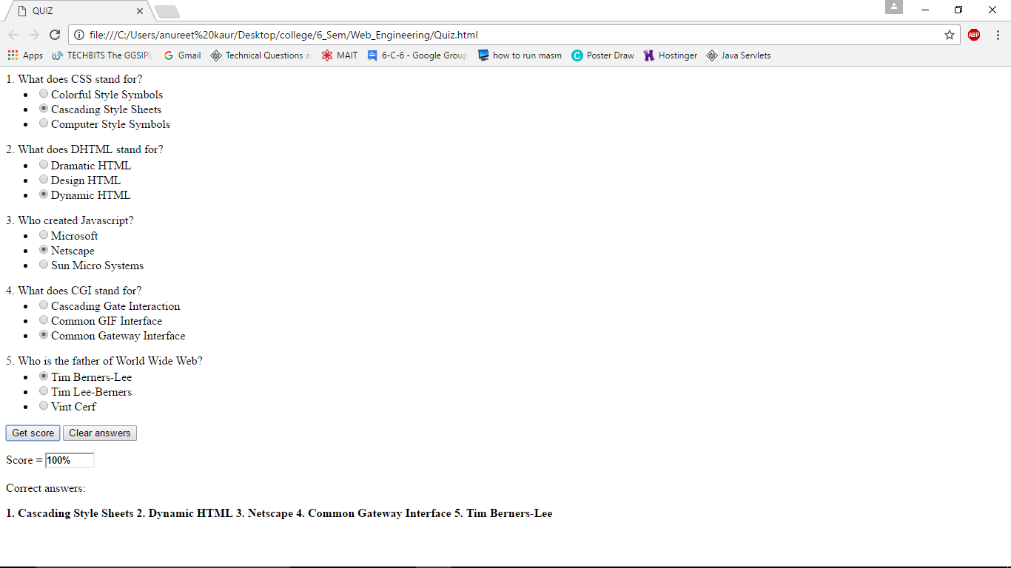

**EXPERIMENT – 15**

**AIM**

Design a website of minimum 5 webpages including one for login and one for index.

**SOURCE FILE**

*login.html*

<html>

<head>

<title>LOGIN</title>

</head>

<style>

*

{

margin: 0;

padding: 0;

}

body

{

background: #EFE6E6;

margin-left:4%;

margin-right: 4%;

font-family:Tahoma, Geneva, sans-serif;

overflow-y: scroll;

overflow-x:hidden;

height:100%;

}

#page1

{

width:70%;

margin:auto;

box-shadow:0 0 10px #1F9E41;

padding-left: 30px;

margin-top:225px;

padding-top:15px;

padding-bottom:15px;

}

#name,#pass

{

font-size: 15px;

margin-bottom: 5px;

padding: 5px;

width:40%;

margin-right:10px;

}

#login

{

background: #8011CC;

width:50%;

padding: 5px;

color:#ffffff;

cursor: pointer;

margin-bottom: 10px;

}

</style>

<script language="javascript">

function check(form)

{

if(form.name1.value == "Anureet" && form.pass1.value == "Welcome")

{

window.open('index1.html');

window.close('login.html');

}

else

{

alert("Error Password or Username");

}

}

</script>

<body>

<div id="page1">

<form name="login">

<center><input id="name" type="text" name="name1" placeholder="Enter Name"></center><br>

<center><input id="pass" type="password" name="pass1" placeholder="Enter Password"></center><br>

<center><input id="login" type="submit" value="LOGIN" onclick="check(this.form)"></center>

</form>

</div>

</body>

</html>

*index1.html*

<html>

<head>

<title>INDEX</title>

</head>

<style>

*

{

margin: 0;

padding: 0;

}

body

{

background: #EFE6E6;

margin-left:4%;

margin-right: 4%;

font-weight: bold;

font-family: 'Oleo Script', cursive;

overflow-y: scroll;

overflow-x:hidden;

height:100%;

}

#page2

{

width:70%;

margin:auto;

box-shadow:0 0 10px #1F9E41;

padding-left: 30px;

margin-top:225px;

padding-top:15px;

padding-bottom:15px;

padding-right: 30px;

}

</style>

<body>

<div id="page2">

<table border="3" cellpadding="10px" cellspacing="10px"width="100%">

<tr>

<td><center><a href="HTML.html" style="font-size:30px;">HyperText Markup Language</a></center></td>

</tr>

<tr>

<td><center><a href="CSS23.html" style="font-size:30px;">Cascading StyleSheets</a></center></td>

</tr>

<tr>

<td><center><a href="Javascript.html" style="font-size:30px;">Javascript</a></center></td>

</tr>

</table>

</div>

</body>

</html>

*HTML.html*

<html>

<head>

<title>HTML</title>

</head>

<style>

*

{

margin: 0;

padding: 0;

}

body

{

background: #EFE6E6;

margin-left:4%;

margin-right: 4%;

font-weight: bold;

font-family: 'Oleo Script', cursive;

overflow-y: scroll;

overflow-x:hidden;

height:100%;

}

#page3

{

width:70%;

margin:auto;

box-shadow:0 0 10px #1F9E41;

padding-left: 30px;

margin-top:225px;

padding-top:15px;

padding-bottom:15px;

text-align:justify;

padding-right: 30px;

}

#back

{

text-align:right;

font-weight: bold;

font-family: 'Oleo Script', cursive;

}

</style>

<body>

<div id="back">

<a href="index1.html">BACK TO INDEX</a>

</div>

<div id="page3">

<p>

Hypertext Markup Language (HTML) is the standard markup language for creating web pages and web applications. With Cascading Style Sheets (CSS) and JavaScript it forms a triad of cornerstone technologies for the World Wide Web. Web browsers receive HTML documents from a webserver or from local storage and render them into multimedia web pages. HTML describes the structure of a web page semantically and originally included cues for the appearance of the document.

</p>

<p>

HTML elements are the building blocks of HTML pages. With HTML constructs, images and other objects, such as interactive forms, may be embedded into the rendered page. It provides a means to create structured documents by denoting structural semantics for text such as headings, paragraphs, lists, links, quotes and other items. HTML elements are delineated by tags, written using angle brackets.

</p>

<p>

HTML can embed programs written in a scripting language such as JavaScript which affect the behavior and content of web pages. Inclusion of CSS defines the look and layout of content. The World Wide Web Consortium (W3C), maintainer of both the HTML and the CSS standards, has encouraged the use of CSS over explicit presentational HTML since 1997.

</p>

</div>

</body>

</html>

*CSS23.html*

<html>

<head>

<title>CSS</title>

</head>

<style>

*

{

margin: 0;

padding: 0;

}

body

{

background: #EFE6E6;

margin-left:4%;

margin-right: 4%;

font-weight: bold;

font-family: 'Oleo Script', cursive;

overflow-y: scroll;

overflow-x:hidden;

height:100%;

}

#page4

{

width:70%;

margin:auto;

box-shadow:0 0 10px #1F9E41;

padding-left: 30px;

margin-top:225px;

padding-top:15px;

padding-bottom:15px;

text-align:justify;

padding-right: 30px;

}

#back

{

text-align:right;

font-weight: bold;

font-family: 'Oleo Script', cursive;

}

</style>

<body>

<div id="back">

<a href="index1.html">BACK TO INDEX</a>

</div>

<div id="page4">

<p>

Cascading Style Sheets (CSS) is a style sheet language used for describing the presentation of a document written in a markup language. Although most often used to set the visual style of web pages and user interfaces written in HTML and XHTML, the language can be applied to any XML document, including plain XML, SVG and XUL, and is applicable to rendering in speech, or on other media. Along with HTML and JavaScript, CSS is a cornerstone technology used by most websites to create visually engaging webpages, user interfaces for web applications, and user interfaces for many mobile applications.</p>

<p>

CSS is designed primarily to enable the separation of document content from document presentation, including aspects such as the layout, colors, and fonts. This separation can improve content accessibility, provide more flexibility and control in the specification of presentation characteristics, enable multiple HTML pages to share formatting by specifying the relevant CSS in a separate .css file, and reduce complexity and repetition in the structural content.

</p>

</div>

</body>

</html>

*Javascript.html*

<html>

<head>

<title>JavaScript</title>

</head>

<style>

*

{

margin: 0;

padding: 0;

}

body

{

background: #EFE6E6;

margin-left:4%;

margin-right: 4%;

font-weight: bold;

font-family: 'Oleo Script', cursive;

overflow-y: scroll;

overflow-x:hidden;

height:100%;

}

#page5

{

width:70%;

margin:auto;

box-shadow:0 0 10px #1F9E41;

padding-left: 30px;

margin-top:225px;

padding-top:15px;

padding-bottom:15px;

text-align:justify;

padding-right: 30px;

}

#back

{

text-align:right;

font-weight: bold;

font-family: 'Oleo Script', cursive;

}

</style>

<body>

<div id="back">

<a href="index1.html">BACK TO INDEX</a>

</div>

<div id="page5">

<p>

JavaScript is a high-level, dynamic, untyped, and interpreted programming language. It has been standardized in the ECMAScript language specification. Alongside HTML and CSS, JavaScript is one of the three core technologies of World Wide Web content production; the majority of websites employ it, and all modern Web browsers support it without the need for plug-ins. JavaScript is prototype-based with first-class functions, making it a multi-paradigm language, supporting object-oriented, imperative, and functional programming styles. It has an API for working with text, arrays, dates and regular expressions, but does not include any I/O, such as networking, storage, or graphics facilities, relying for these upon the host environment in which it is embedded.</p>

<p>

Although there are strong outward similarities between JavaScript and Java, including language name, syntax, and respective standard libraries, the two are distinct languages and differ greatly in their design. JavaScript was influenced by programming languages such as Self and Scheme.</p>

</div>

</body>

</html>

**OUTPUT**

